Philadelphia University
Faculty of Information Technology
Department of Software Engineering

Lecturer: Mr. A. Obidat,
Mrs. H. Hardan
Coordinator: Mr. A. Obidat
Internal Examiner: Dr. A. Fuad

Object Oriented Data Structure (721221+ 721211)
Time: 60 minutes first exam

Student Name: Student #:

Information for Candidates
- This examination paper contains 5 questions on 3 pages totaling (20) marks.
- The marks of questions are shown in round brackets. (-- marks).
Advice to Candidates
1- You should attempt all questions.
2- You should write your answers clearly.

I. Basic Notions
Objectives: The aim of the questions in this part is to evaluate the required minimal student knowledge and skills. Answers in the pass category represent the minimum acceptable standard

Question 1: Assume that stack is an object of the class ArrayStack, and you can store and retrieve variables of type int in stack. What is the output of the following segment of code? (3 marks)

stack.push(5);
stack.push(4);
stack.push(2);
stack.push(stack.top() + 1);
int x1 = stack.top();
stack.pop();
System.out.println(x1);
System.out.println(stack.top());
while (!stack.isEmpty())
{
x1 = stack.top();
stack.pop();
System.out.println(x1);
}
System.out.println(stack.TopIndex);

Sol:-
Output:
3
2
2
4
5
-1

II. Familiar Problems Solving
Objectives: The aim of the questions in this part is to evaluate that have some basic knowledge of the key aspects of the lecture material and can attempt to solve familiar problems.

Question 2: Add new method for following ArrayQueue this called EmptyAll this operation will empty the queue from all its items. (4 marks)
public class ArrayQueue implements QueueInterface
{
private Object[] queue;
private int capacity;
private int numItems = 0;
private int front = 0;
private int rear = -1;
}

Sol:-
Public void EmptyAll( )
{
While(numItems != 0)
{
queue[front] = null;
front = (front + 1) % capacity;
numItems = numItems - 1;
}
}

Question 3: m_push is a modified push operation which has the following code:
(4 marks)

public void m_push(Object item)
{
StackNode newNode = new StackNode();
newNode = top;
newNode.info = item;
newNode.link = top;
top = newNode;
}

After execute the operation “ myStack.m_push(F) “ on the following stack:
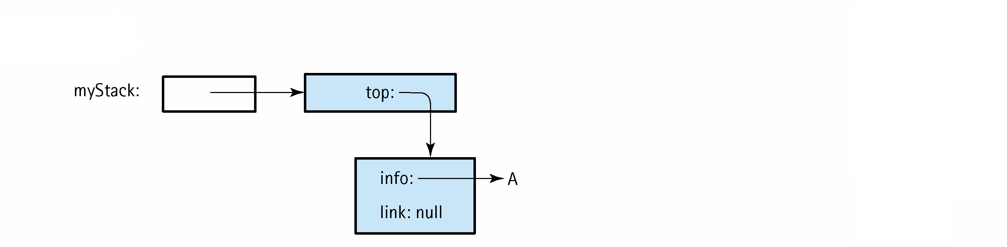

- Draw the result stack.
- Modify the above code so it will work as a regular stack push operation.

Sol:
a)
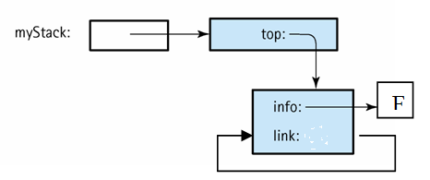

b)
public void m_push(Object item)
{
StackNode newNode = new StackNode();
newNode.info = item;
newNode.link = top;
top = newNode;
}

Question 4: The list nodes have an info variable containing an integer and a next variable containing a reference, and list, ref1, and ref2 are references to a list node. (4 marks)

Write one statement to do each of the following:
a. Make list point to the node containing 30.
b. Delete first node in the list without using any methods.
c. Set the info variable of the node containing 60 to 62.
d. What is the value of ref1.next.info.

Sol:
a) list = list.next ;

b) list = list.next ;

c) ref1.next.next.info = 62

d) 45

III. Unfamiliar Problems Solving
Objectives: The aim of the questions in this part is to evaluate that you can make progress towards the solution of unfamiliar problems, and can set out reasoning and explanation in a clear and coherent manner.
Question 5: A polynomial function is a function that can be defined by evaluating a polynomial. A function ƒ of one argument is called a polynomial function if it satisfies (5 marks)
for all arguments x, where n is a non-negative integer called exponent and a₀, a₁,a₂, ..., a_{n} are constant coefficients.
For example,
If we want to use linked list structure to implement one argument polynomial function.
- Modify the following inner class so it can represent one argument polynomial function.

protected class ListNode
{
protected Listable info;
protectedListNode next;
}

- Draw the list that will implement the following function:

F(x) =

Sol:
a)
protected class ListNode
{
protected Listable exponent;
protected Listable coefficients;
protectedListNod e next;
}

