Philadelphia University
Faculty of Information Technology
Department of Software Engineering
Examination Paper
Lecturer : Dr. Ali Fouad, Mr. Abdalrahman Obidat
Coordinator : Dr. Ali Fouad
Internal Examiner : Dr. Maouche Mourad

Object Oriented Data Structures (721211) Section: 1 Final Exam First Semester of 2015-2016
Date: 1- 2- 2016 Time: 120 minutes

Information for Candidates
- This examination paper contains six questions, totaling 20 marks.
- The marks for parts of questions are shown in round brackets.

Advice to Candidates
1. You should attempt all questions.
2. You should write your answers clearly.
I. Basic concepts
Objective: The aim of the question in this part is to evaluate your knowledge and skills concerning with the basic concepts of array list and linked list data structures.

Question1 (10 marks)
Circle the correct answer for each problem
1. Suppose current position refers to a node in a linked list. What statement changes cursor so that it refers to the next node?
A. cursor++; B. cursor = link; C. cursor += link; D. cursor = cursor.link;

2. Which boolean expression indicates whether the numbers in two nodes (p and q) are the same. Assume that neither p nor q is null.
A. p == q B. p.data == q.data C. p.link == q.link D. None of the above.

3. What kind of list is best to answer questions such as "What is the item at position n?"
A. Lists implemented with an array. B. A+C
C. Singly-linked lists. D. None of the above.

4. The operation for adding an entry to a stack is traditionally called:
A. add B. append C. insert D. push

5. Which of the following stack operations could result in stack underflow?
A. is_empty B. pop C. push D. Two or more of the above answers

6. If the characters 'D', 'C', 'B', 'A' are placed in a queue (in that order), and then removed one at a time, in what order will they be removed?
A. ABCD B. ABDC C. DCAB D. DCBA

7. Consider the following stack with the indicated initials status and series of stack operations.
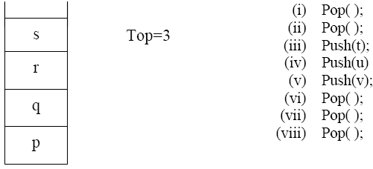
If the above series of operation is performed, what is final position of top and contents of the top respectively?
a) 1 , v
b) 1 , t
c) 1 , q
d) 2 , u

8. Which of the following trees are heaps?
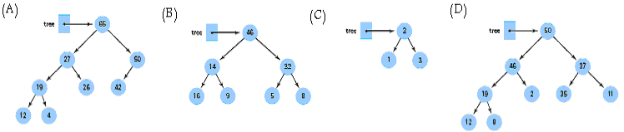
a) A
b) D + B
c) D + C
d) D

9. Which of the following definitions is not suitable for Queue operations?
a) Clear( ) – clear the data structure.
b) Delete( )- remove the most recently inserted item from the application.
c) Is_full( ) – check to see if the application is full.
d) Is_empty – check to see if the application is empty.

10. Consider the following diagram and set of operations.
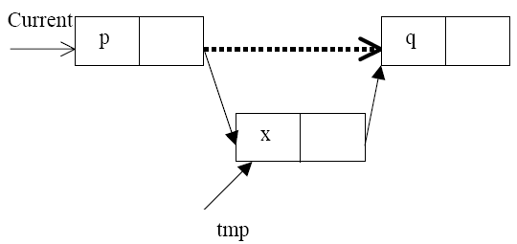

If current is reference to node that we need to insert temp node with value = x after it. Which of the following is a /are more suitable java code(s) corresponding to insert tmp node?
a) tmp= new Node( null, null); tmp.data= tmp;
tmp.next = current.next; current.next= x;
b) tmp= new Node (( null, null);tmp.data= tmp;
current.next = tmp.next; current.next= tmp;
c) tmp= new Node ( null, null);tmp.data= x;
tmp.next = current.next;current.next= tmp;
d) tmp= new Node ( null, null);tmp.data= tmp;
tmp.next = current.next;current.next= tmp;

Question2 (2 marks)
Doubly linked list has data part and two references “next” and “back” , where back refer to previous node. The following figure represents inserting process into a doubly linked list
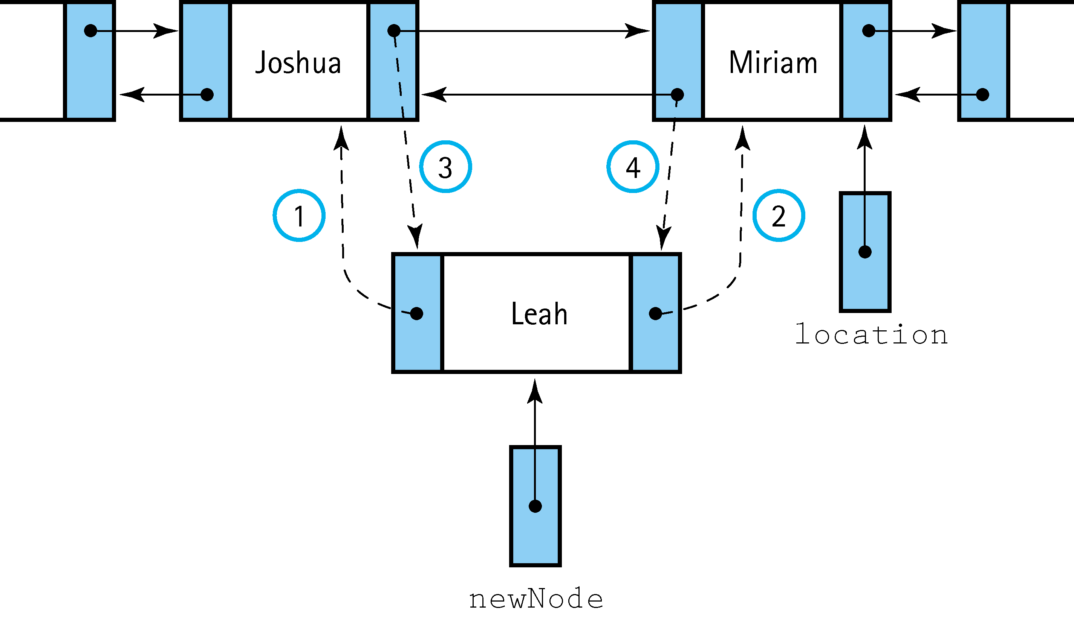
Write the code corresponding to each circled number in this figure.

II. Familiar Problem Solving
Objective: The aim of the question in this part is to evaluate your knowledge to solve familiar problems in unsorted array list and sorted array list data structures.

Question 3: (10 marks)
Assume that the following numbers 6, 2, 9, -11, 7, 10, -2, 8, -5, -1 are inserted into initially empty BinarySearchTree in the given order.

(a) Show how the binary search tree looks like after each individual complete insertion (addElement operation) has taken place. (3 marks)
(b) Show how the final binary search tree from question (a) will look like after removing 8 and 2. (3 marks)
c) Consider the expression tree given below. (4 marks)

8

3
9
2

5

6

4

What is the order of nodes of tree if traverse in the following sequence Pre-order, In-order, and Post-order?

Question4 (6 marks)
a) Redraw the following priority queue after inserting 7 and 32.

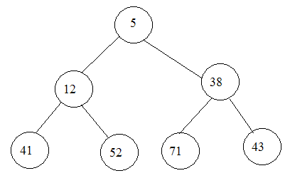

b) Suppose you have the following values:
47, 90, 140, 145, 153, 393, 620,
Insert the values into a hash table that uses the hash function key % 10 and solve collision using chaining.

Question6 (5 marks)
Write an O(N) function print_join() which prints the contents of two ordered list in the sorted order. The arguments to the function are the two ordered lists. For example, if the input lists are L1 = {Bob, Jil, Ned}, L2 = {Al, Bob, Cal, Xi}, then the output will be: Al, Bob, Bob, Cal, Jil, Ned, Xi

Solution

void print_join(SortedLinked L1, SortedLinked L2 ) 1 mark
{
for(int i=0; i< L2.size(); i++)
L1.insert(L2.get(i)); 2 marks

for(int j=0; j< L1.size(); j++)
System.out.println(L1.get(j)); 2 marks
}

III. Unfamiliar Problem Solving
Objective: The aim of the questioning this part is to evaluate that student can solve familiar problems with ease and can make progress toward the solution of unfamiliar problems, and can set out reasoning and explanation in clear and coherent manner.

Question6 (5 marks)
Two stacks of positive integers are needed. One stack contains even integers; the other contains odd integers. The total number of elements in the combined stacks is never more than 200 at any time, but we cannot predict how many are in each stack. Can you think of a way to implement both stacks in one array? And Write the definitions for such a double-stack structure.

