Philadelphia University |  |  | Faculty of information Technology
Coordinator: Mrs.Hanan Hardan |  |  | Department of Computer Science
Internal Examiner: Dr. Murad Magableh |  |  | Examination Paper
Computer Skills (9761111)  Computer Skills – Humanities (0710103) | First Exam |  | Summer Semester of Academic Year 2012/2013
Date: 3/7/2013 |  |  | Time: 50 minutes A
Student No.: ...................................... Student Name: .............................................................
Lecturer: .......................................... Section No.: ..................................................................

Information for candidates
- This examination paper contains 20 questions, totaling 20 marks
- Marks of Each Question is 1.

Advice to Candidates
1. You should attempt all questions.
2. You should write your Answers clearly in the specified place in the first page.

Question | Answer
1
2
3
4
5
6
7
8
9
10
11
12
13
14
15
16
17
18
19
20

Q1: In the picture below; the dialog box displayed is used to delete, edit, filter and create range names, the name of the dialog box is:
Student No.: ...................................... Student Name: .............................................................
Lecturer: .......................................... Section No.: ..................................................................
- Define Name
- Range Name
- Range Name Edit
- Name Manager

Q2: The result of the formula = ROUND (1000.6111,2) is:
- 100
- 10
- 1000.61
- 1000.62

Q3: In the picture below; the reference of the cell which has comment is:
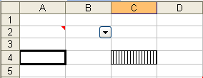
- A4
- C4
- A2
- B2

Q4: The range of cells that contains cell C5 is:
- C1:C10
- A3:D3
- B1:D4
- None of the above

Q5: Which of the following is an example of a correctly written Excel formula?
- =SUM(B1:B4)
- (B1:B4)
- B5 = SUM(B1+B4)
- SUM=(B1..B4)

Q6: In the picture below; the active sheet in the displayed workbook is:
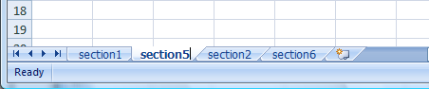
- Section1
- Section2
- Section5
- Section6

Q7: How many arguments (معاملات) does function TODAY take?
- 0
- 1
- 2
- None of the above

Q8: If you have copied a cell having the formula =AVERAGE(12,12,12), then you have used Paste Special displayed in the picture below, what would be the result of the Paste special?
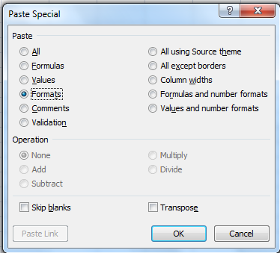
- The formula =AVERAGE(12,12,12) and the value 12
- Only the formula =AVERAGE(12,12,12)
- Only the value 12
- None of the above

Q9: In the picture below; the result of the formula =IF(OR(A2="Fadi",B2<50),PROPER("welcome"),"bad") is:
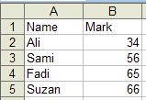
- Welcome
- bad
- TRUE
- WELCOME

Q10: In the picture below; to remove the dropdown arrows displayed at the table header, go to:
- Design tab ➔ Tools group ➔ select Convert to range
- Home tab ➔ Styles group ➔ select Format as Table ➔ select remove filtering
- Home tab ➔ Styles group ➔ select format as Table ➔ select Convert to range
- None of the above

Q11: The result of the formula MID(RIGHT(LEFT(“this is my first exam”,21),21),21) is:
- this is my first exam
- this is my
- this is
- this is my first

Q12: When the workbook is protected for structure then:
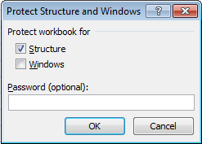
- Any sheet in the workbook cannot be deleted
- The window of any sheet in the workbook cannot be minimized
- The formula in any sheet in the workbook cannot be modified
- All of the above

Q13: In the picture below; the result of the formula =SUMIF(A3:A16,"Aqaba",C3:C16)+SUMIF(A3:A16,"Irbid",C3:C16)
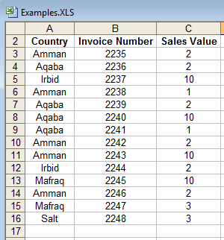
- 15
- 12
- 27
- 54

Q14: In the picture below; the result of the formula = COUNTIF(B2:B5,”>65”) is:
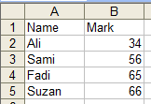
- 0
- 2
- 65
- 1

Q15: In the picture below; which of the following is TRUE about the vertical axis in the chart displayed?
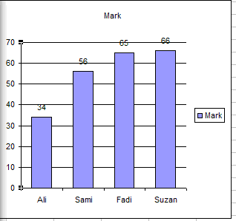
- Major unit is 10
- The maximum value is “Suzan”
- Values in reverse order check box is selected
- All of the above

Q16: In the picture below; what is the last row in the displayed table after you sort it according to the Sort dialog?
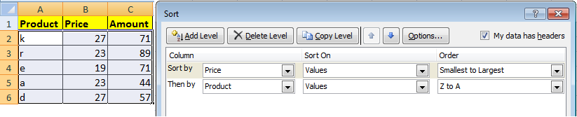
- d, 27, 57
- e, 19, 71
- k, 27, 71
- a, 23, 44

Q17: In the picture below; the formula which has the result "A" is:
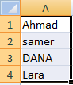
- =LEFT(UPPER(A4),2)
- =MID(A3,2,1)
- =RIGHT(A4,1)
- All of the above

Q18: In the picture below; the result of the formula =TRIM(B2) appears (تظهر) in cell:
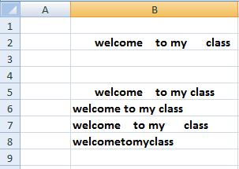

- B5
- B6
- B7
- B8

Q19. In the picture below, the option chosen on chart No.2 was:
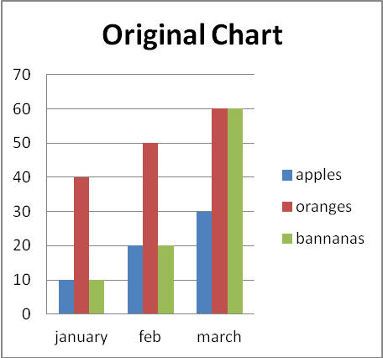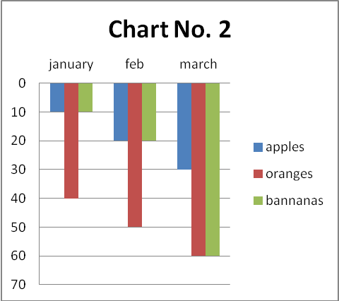

- Logarithmic scale
- Values in reverse order
- Display unit
- None of the above

Q20: In the picture below; how many segments are exploded in the displayed chart?
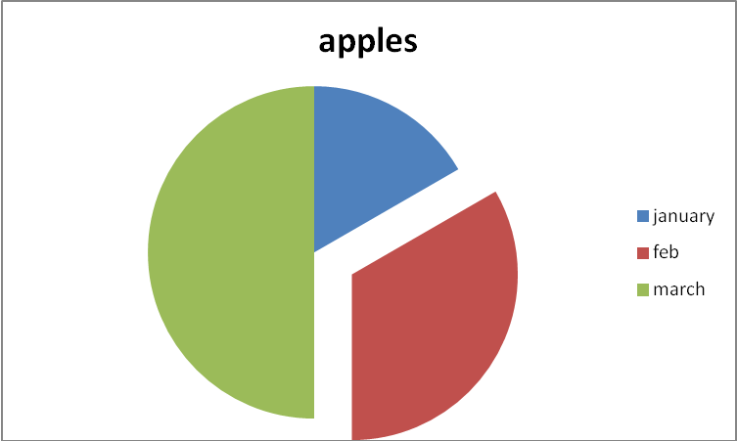
- 0
- 1
- 2
- 3

Good Luck!

