Philadelphia University |  |  | Faculty of information Technology
Coordinator: Mrs. Hanan Hardan |  |  | Department of Computer Science
Internal Examiner: Dr. Murad Magableh |  |  | Examination Paper
Computer Skills (9761111)  Computer Skills – Humanities (0710103) | First Exam |  | Summer Semester of Academic Year 2012/2013
Date: 3/7/2013 |  |  | Time: 50 minutes B
Student No.: ...................................... Student Name: .............................................................
Lecturer: .......................................... Section No.: ..................................................................

Information for candidates
- This examination paper contains 20 questions, totaling 20 marks
- Marks of Each Question is 1.

Advice to Candidates
1. You should attempt all questions.
2. You should write your Answers clearly in the specified place in the first page.

Question | Answer
1
2
3
4
5
6
7
8
9
10
11
12
13
14
15
16
17
18
19
20

Q1: The function used to display both current date and current time is:
Student No.: ...................................... Student Name: .............................................................
Lecturer: .......................................... Section No.: ..................................................................
- NOW()
- TODAY()
- TIME()
- All of the above

Q2: In the picture below; the cell reference of the selected cells is:

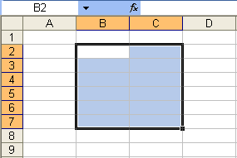

- B2:B7
- 7B:7C
- B7:C7
- B2:C7

Q3: In the picture below; number of sheets in the displayed workbook is:

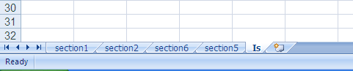

- 5
- 1
- 3
- 4

Q4: In the picture below; the small red triangle in the top right corner of cell A2 means:

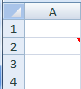

- There is an error in the cell
- The cell can be used only to insert a formula
- The font color of the cell is red
- There is a comment inserted into the cell

Q5: What is the output of the following equation; =PROPER("this is A final test") ?
    - This Is A Final Test
    - this is a final test
    - THIS IS A FINAL TEST
    - None of above

Q6: One of the following is NOT considered (يعتبر) a Statistical function:
- COUNTIF
- SUMIF
- COUNTBLANK
- All of the above

Q7: The result of the function =ROUND(364.667,3) is:
- 364.667
- 364.3
- 364.700
- 364

Q8: In the picture below, when applying the following formula on the displayed table,
=IF(OR(COUNT(C3:C5) > 30,TRUE),COUNT(A3:A5),10), the result should be:

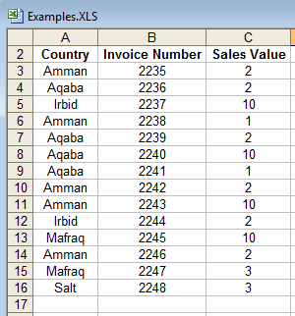

- 0
- 3
- 10
- None of the above

Q9: If you have specified a password to modify your Excel workbook (from general options in "Save As" dialogue box), then you:
- Can save the changes on the same workbook without the password
- Can save the changes without the password if you save the workbook under a different file name
- Cannot open the file without the password
- None of the above

Q10: In the pictures below; when sorting the table according to the displayed Sort dialog, the value of Mark2 in the first row will be:

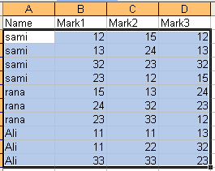
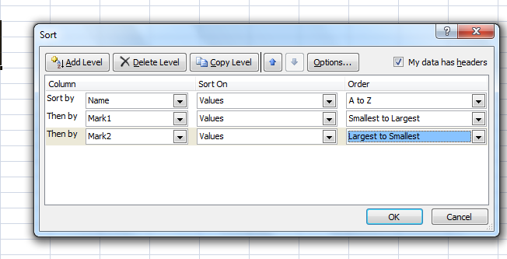
- 22
- 11
- 33
- 15

Q11: In the picture below; you choose Structure option to:

- Prevent users from moving windows
- Prevent users from deleting, copying, moving or inserting worksheets
- Prevent users from resizing windows
- Prevent users from closing windows

Q12: The result of the formula MID(RIGHT(LEFT(“this is my first exam”,21),21),21) is:
- this is my first exam
- this is my
- this is
- this is my first

Q13: In the picture below; the operation in the displayed paste special dialogue box that is used to paste row data in a column or column data in a row is:

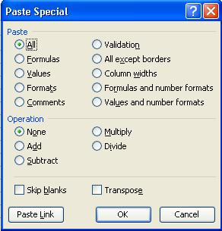

- Formulas
- Skip blanks
- Column widths
- Transpose

Q14: In the picture below; to find the sum of all Sales in Aqaba, then you have to use the following formula:

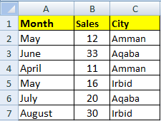

- =SUMIF(C2:C7,C3,B2:B7)
- =SUMIF(C2:C7,"Aqaba")
- =SUMIF(B2:B7,C3)
- =SUMIF(B2:B7,"Aqaba",C2:C7)

Q15: In the picture below; depending on the displayed Define name dialog box, the result of the formula =COUNT(row) is:

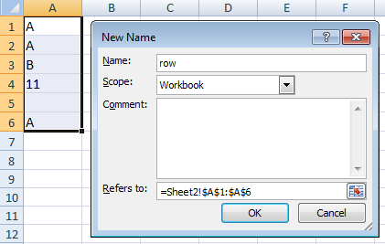

- 4
- 1
- 5
- 11

Q16: In the picture below; the format of cell A4 after applying the conditional formatting is:

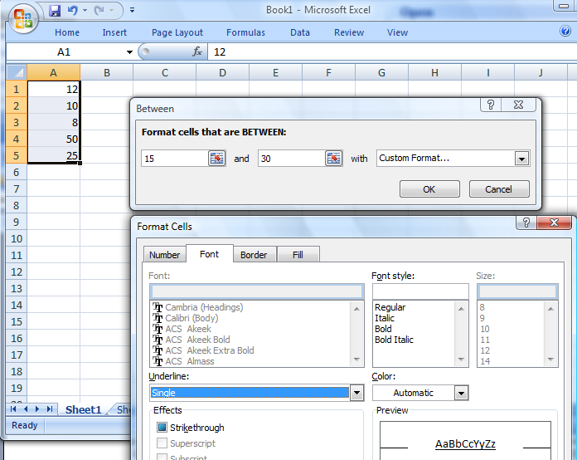

- Dotted (نقطي) border
- Bold
- Single Underline
- No format

Q17: The statistical function that can find out how many Employees are being paid a salary that is more than 300 is:
- IF
- SUMIF
- COUNT
- COUNTIF

Q18: When you change the Scale of the value Axis, If you select values in reverse order from Format Axis window then the resulted chart for the following table is:

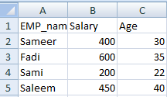

- 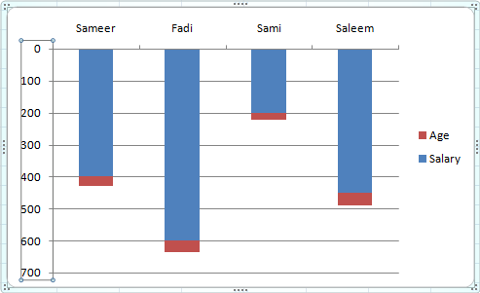

- 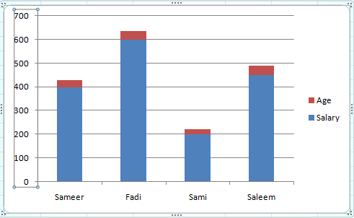

- 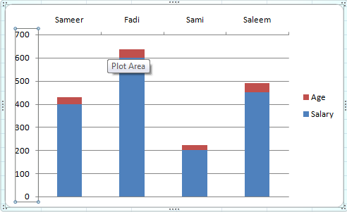

- None of the above

Q19: In the picture below; which of the following you can do to the displayed chart:
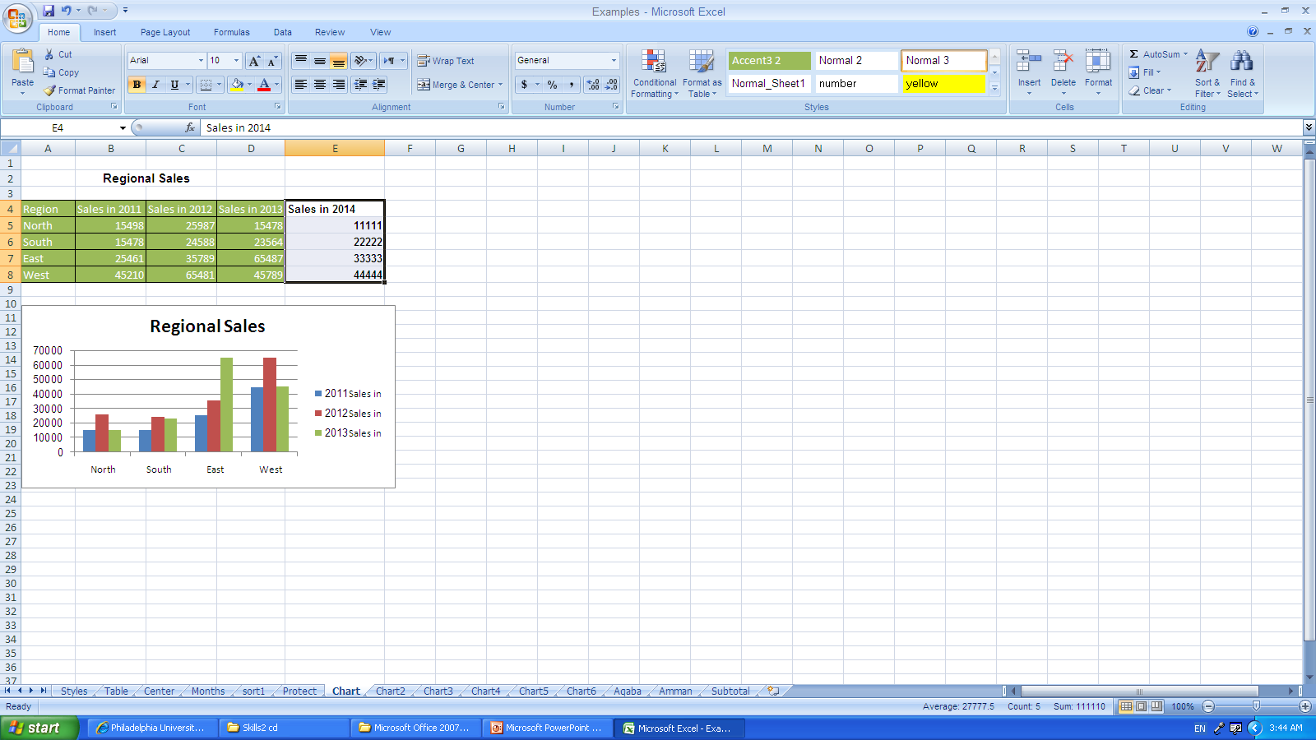
- Add “Sales in 2014” data series to the chart
- Delete “Sales in 2011” data series from the chart
- Repositioning the chart legend and title
- All of the above

Q20: In the picture below; if you format (Y) Axis of “The Original Chart” according to the displayed Format Axis dialog box, then the chart will look like the one which has number:
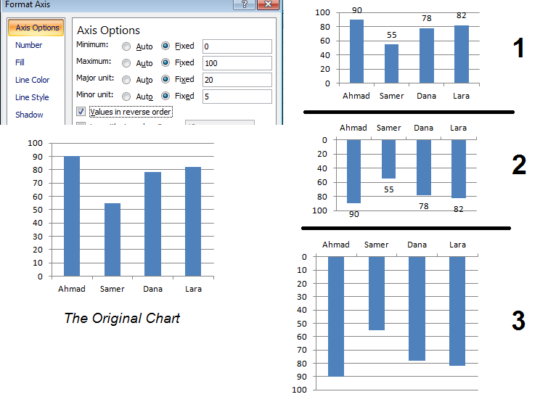
- 1
- 2
- 3
- None of the above

Good Luck!

