Question 1 Answers: [6Marks, 1 mark each]
1 | 2 | 3 | 4 | 5 | 6

Question2: [6 Marks, 1 mark each]

Find the output of the following C++ code segments:

Code Segments | Answer:
A: | Two // 0.5 Point Three // 0.5 point
B: | 4 // 0.5 point  n = 4 // 0.5 point
C: | 8 // 0.5 mark  6 // 0.5 mark
D: | C++ Mid Exam 2025_2026 // 1 point
E: | 11 // 0.5 point  The End // 0.5 point

F: | 8! // 1 point

Question3: [5 Marks]
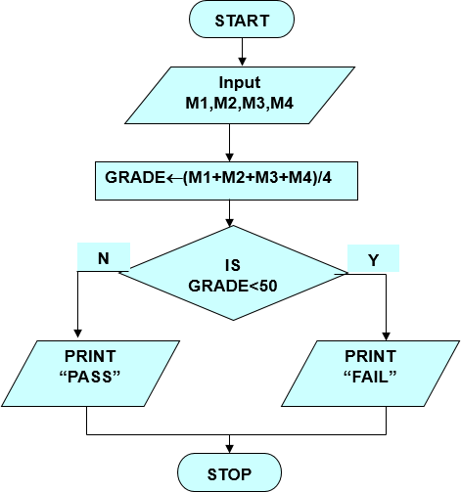

Question 4 : [6 Marks]
Answer :
#include <iostream> using namespace std; int main()
{ // 0.5 mark for above statements int fnum; // 0.5 mark
cout<<"Enter fuculty number"; // 0.5 mark cin>>fnum; // 0.5 mark
if(fnum == 7) // 0.5 mark cout<<"IT faculty"; // 0.5 mark
else if(fnum == 2) // 0.5 mark cout<<"Science faculty"; // 0.5 mark
else if(fnum==6) // 0.5 mark cout<<"Engineering faculty"; // 0.5 mark
else // 0.5 mark
cout<<"Invalid faculty number"; // 0.5 mark return 0;
}

Question 5 : [4 Marks]
Find and correct syntax errors in the following c++ code:

Answer:
int num1, num2; // Added semicolon cin >> num1; // Corrected operator
cout << "The sum of two numbers is: " << sum << endl; // Corrected cout syntax

} // end // 1 point for each

Question 4: [3 Marks]

Solution

#include <iostream> using namespace std; int main()
{
double R1, R2; // 0.5 point
cout << "Enter the radius of the first (larger) circle: "; cin >> R1; // 0.25 point
cout << "Enter the radius of the second (smaller) circle: "; cin >> R2; // // 0.25 point
double areaLarge = 3.14 * R1 * R1; // 0.5 point double areaSmall = 3.14 * R2 * R2; // 0.5 point
double shadedArea = areaLarge - areaSmall; //0.5 point
cout << "The shaded area is: " << shadedArea << endl; // 0.5 point return 0;
}

