Question 1 Answers:
1 | 2 | 3 | 4 | 5 | 6
C | A | A | B | D | B

Question2: [6 Marks, 1 mark each]
Find is the output of the following C++ code segments:

Code Segments | Answer:
A: | B // 0.5 point  Program finished // 0.5 point
B: | 9 // 0.5 point  A = 9// 0.5 point
C: | A // 0.5 mark  8 // 0.5 mark
D: | 2025_2026 // 1 point
E: | 21 // 0.5 point  The End // 0.5 point

F: | 9!! // 1 point

Question3: [5 Marks]
Start 0.5 point , End 0.5 point , // Max = value1 , Max = value2 0.5 , 0.5 points // Input , condition , print 1 point , 1 point , 1 point
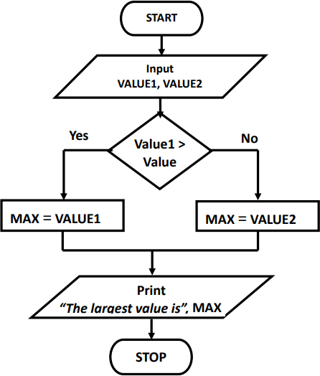

Question 4 : [6 Marks]
Answer:
#include <iostream> using namespace std; int main()
{ // 0.5 mark for above statements
int dnum; // 0.5 mark
cout<<"Enter department number"; // 0.5 mark
cin>>dnum; // 0.5 mark
if(dnum == 750) // 0.5 mark
cout<<"CS Department"; // 0.5 mark
else if(dnum == 721) // 0.5 mark
cout<<"SE Department"; // 0.5 mark
else if(dnum==741) // 0.5 mark
cout<<"AI Department"; // 0.5 mark
else // 0.5 mark
cout<<"Invalid department number"; // 0.5 mark
return 0;
}

Question 5 : [4 Marks]
Find and correct syntax errors in the following c++ code:

#include <iostream> using namespace std; int main()
{
double mark ; string name = "Ali"; cin>> mark;
mark = mark +2;
cout<< name << " new mark is = "<< mark <<endl; return 0;
}

Question 4: [4 Marks]

Solution

// Online C++ compiler to run C++ program online #include <iostream>
using namespace std; int main()
{ double L1, L2, shadedArea; // 0.5 point
cout << "Enter the side length of the first (larger) square: "; cin >> L1; // 0.25 point
cout << "Enter the side length of the second (smaller) square: "; cin >> L2; // 0.25 point
double areaLarge = L1 * L1; // 0..25 point double areaSmall = L2 * L2; // 0..25 point shadedArea = areaLarge - areaSmall; // 1 point
cout << "The shaded area is: " << shadedArea << endl; // 0.5 point return 0;
}

Good Luck

