Version | Description | Changed By | Date
1.2 | Complete remaining alternate flows except ‘Handle Credit Card Payment’. | Richard Ashwell | 2/6/11

Brief Description: | A sales assistant processes a customer order. The customer pays for the order by cash or credit card. An invoice and, optionally, a picking list and/or delivery note are produced.
Business Trigger: | A customer asks to purchase some goods
Preconditions: | The system is displaying the sales assistant’s main menu

Basic Flow:
Assumptions: All items are in-stock, for collection and available from the store shelves. Customer pays cash.
Line | System Actor Action |  | System Response
 | The sales assistant asks the system to process a new order |  | The system asks the sales assistant for identification
 | The sales assistant identifies themselves to the system (AF1) |  | The system displays a blank order screen with a blank order line and the fulfilment set to ‘collection’ to the sales assistant
 | The sales assistant enters the product number into the system (AF2) |  | The system displays the product number, description, unit price, available stock to the sales assistant.
 | The sales assistant enters the required quantity into the system (AF3) |  | The system displays the total price for the order line and order to the sales assistant. The system adds a blank order line to the order.
 | Steps 3 to 4 may be repeated for additional order lines or to edit existing order lines (AF4)(AF8)
 | The sales assistant confirms completion of the order to the system (AF5) |  | The system asks the sales assistant for payment
 | The sales assistant enters the amount of cash tendered into the system |  | The system displays the required change to the sales assistant. The system opens the cash drawer
 | The sales assistant closes the cash drawer (AF9) |  | The system prints a receipt to the sales assistant. The system displays the main menu to the sales assistant.
Post Condition: |  | The system is displaying the main menu

Alternate Flow (AF1): Handle Invalid Sales Assistant
If at line 2 in the basic flow the user enters an invalid Sales Assistant ID, then:
Line | System Actor Action | System Response
 |  | The system displays a message indicating that the ID is invalid and asking the user to enter a different ID.
The use case restarts at line 2 of the basic flow

Alternate Flow (AF2): Handle Invalid Product Number
If at line 3 in the basic flow the user enters an invalid product number, then:
Line | System Actor Action | System Response
 |  | The system displays a message indicating that the product number is invalid and asking the user to enter a different product number.
The use case restarts at line 3 of the basic flow

Alternate Flow (AF3): Make Backorder
If at line 4 in the basic flow the quantity required is greater than the quantity available from stock, then:
Line | System Actor Action | System Response
The system displays an additional order line as a backorder with the required quantity set to the difference between the original required and available quantities and the available stock set to that available in the regional warehouse.
The system asks the Sales Assistant to confirm the backorder.
 | The Sales Assistant confirms the backorder. | The system sets the required quantity of the original order line to the quantity available from stock in the store.
The use case restarts at line 5 of the basic flow

Alternate Flow (AF4): Delete an Order Line
If between lines 3 and 5 of the basic flow, the sales assistant selects ‘Delete’, then:
Line | System Actor Action | System Response
 |  | The system removes the currently selected order line from the order.
The use case restarts at line 5 of the basic flow

Alternate Flow (AF5): Address Required
If at line 6 of the basic flow, an address is required, then:
Line | System Actor Action | System Response
 | The sales assistant confirms completion of the order to the system | The system asks the sales assistant for the customer’s name.
 | The sales assistant enters the customer’s name into the system | The system displays the customer’s name to the sales assistant.
 | The sales assistant enters the customers postcode into the system | The system displays the partially completed address including a list of possible first lines to the sales assistant.
 | The sales assistant chooses the first line of the address that contains the customers house number from the list of first lines displayed | The system displays the completed address to the sales assistant and asks for confirmation.
 | The sales assistant confirms to the system that the address is correct | The system asks the sales assistant for payment.
The use case restarts at line 7 of the basic flow

Alternate Flow (AF6): Handle Credit Card Payment

Alternate Flow (AF7): Cancel Order Processing
If, at any point in the use case where the system is waiting for user input, the Sales Assistant selects ‘Cancel’ then:
Line | System Actor Action | System Response
1 |  | The system asks the Sales Assistant to confirm the cancellation.
2 | The Sales Assistant confirms the cancellation | The system displays the main menu.
The use case terminates.

Alternate Flow (AF8): Select Item For Delivery
If between lines 3 and 5 of the basic flow, the sales assistant wishes to change an order line from ‘Collection’ to ‘Delivery’, then:
1 | The sales assistant selects the line to be changed on the system | The system displays the selection to the sales assistant.
2 | The sales assistant selects ‘Delivery’ on the selected order line | The system displays the selection, adds a new order line to the order with appropriate field values for a delivery charge and updates the total order price to the sales assistant.
The use case restarts at line 5 of the basic flow

Alternate Flow (AF9): Picking List Required
If at line 9 in the basic flow there are any items for collection which are in the store warehouse rather than out on the store shelves, then:
Line | System Actor Action | System Response
1 |  | The system prints a picking list for those items to the store warehouse printer.
The use case restarts at line 9 of the basic flow

Business Rules:
- Backordered items must be displayed in red.
- The system must show any changes that occur to available stock whilst the order is being created.
- At line 8 of the basic flow: The system records the order together with the payment details. The system decrements the stock.

Non Functional Requirements:
- The use case must complete in the fewest possible number of keystrokes - usability

Data Issues:
- It must be possible to enter the product number either using a barcode scanner or via the keyboard

Activity Diagram:

Prototype Screen:
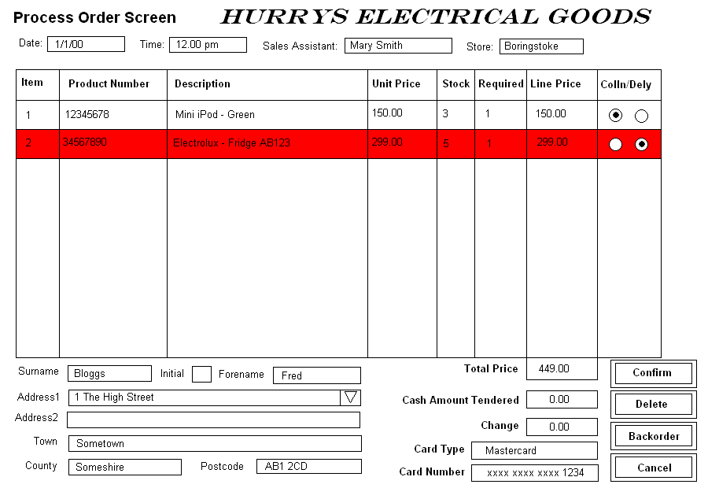

Screen Entry Exception Table: <an optional table for simple exception handling of entries into fields on the prototype screen where adding an alternate flow would be overkill and the flow of the use case remains unchanged. This table could be used in place of the Data Dictionary>
Field | Constraint | Response
- e.g. Customer Surname | 30 chars max | Message: “Exceeds 30 chars max – please re-enter”

