Student Name:

Student Number:

Consider the following scenario that describes the workflow of the use case: Manufacture Order

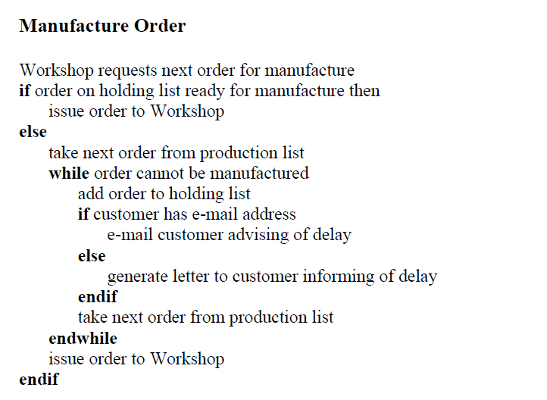

**Draw a large and clean activity diagram associated with the above workflow.**

**Solution**

