Write the Java programming code of the following example.
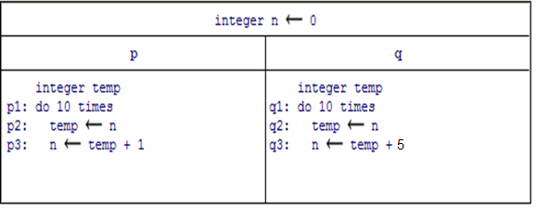

import java.lang.String;
import java.lang.Thread;
class Count1 extends Thread {

public void run() {
int temp;
for (int i = 0; i < 10; i++) {
temp = Count.n;
Count.n = temp + 1;
}
}
}
class Count2 extends Thread {

public void run() {
int temp;
for (int i = 0; i < 10; i++) {
temp = Count.n;
Count.n = temp + 5;
}
}
}

Class Count{
static volatile int n = 0;
public static void main(String[] args) {

Count1 p = new Count1();
Count2 q = new Count2();
p.start();
q.start();
try { p.join(); q.join(); }
catch (InterruptedException e) { }
System.out.println("The value of n is " + n);
}
}

