Quiz #2.

Std Name: ____________________ Std No.: __________________________

Q1: from the Following Figure Answer the following Questions:

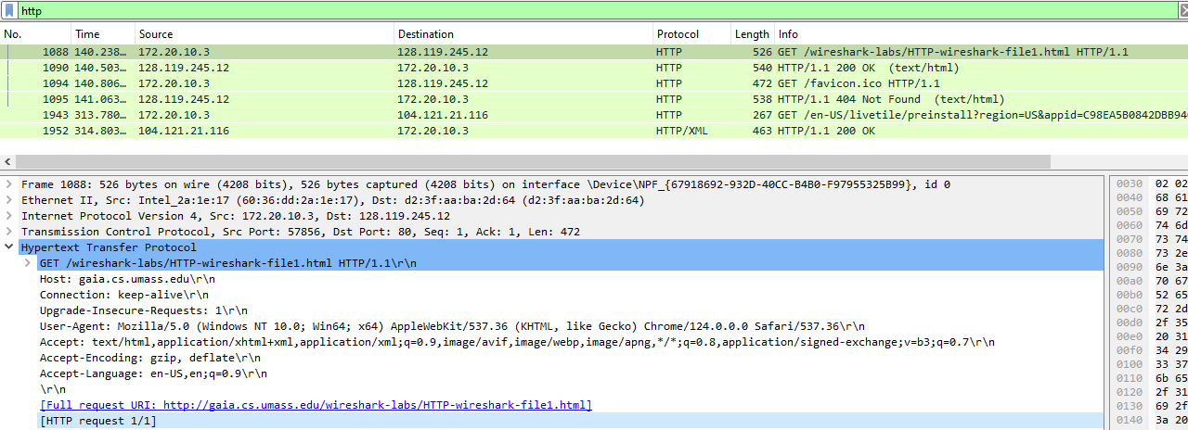

1: What is the HTTP version of this packet?

2: What Language (if any) does the client browser indicate that it can accept to the server?

3: What is the IP address of the client computer?

4: what is the IP address of the http Server?

5: Is this a request or response packet and how do you know?

Q2: From the Following Figure Answer the following Questions:

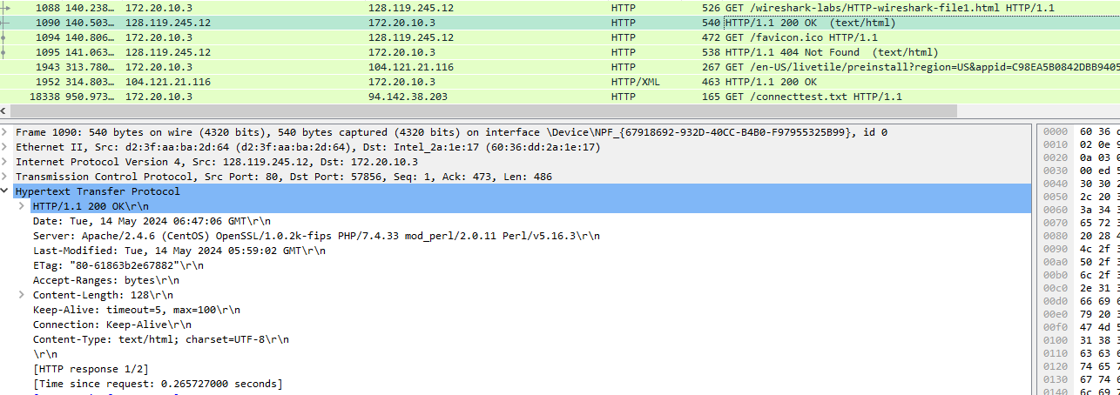

1: What is the status code returned from the server to your browser? And what does it Mean?

2: When was the HTML file that you are retrieving last modified at the server?

3: How many bytes of content are being returned to your browser?

4: Is this a request or response packet and how do you know?

5: what type of servers is used for this packet? Mention two other types of servers can be used for HTTP servers.

Q3: From the Following Figure Answer the following Questions:

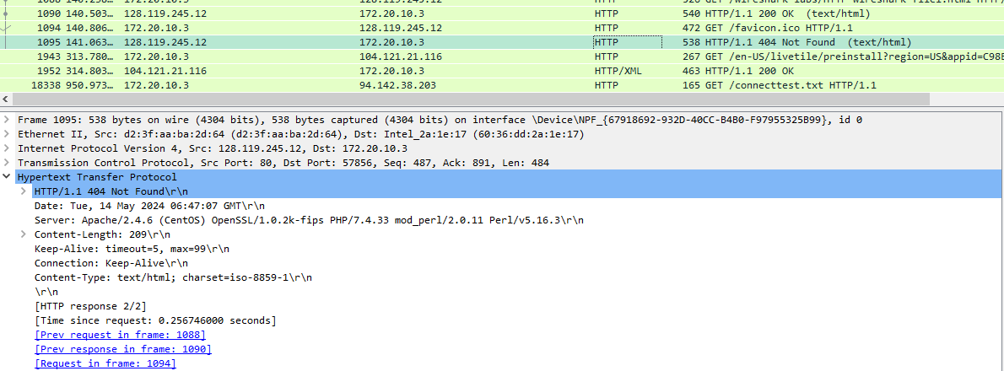

1: Explain the problem connected to this packet. With the detailed scenario.

Q4: From the Following Figure Answer the following Questions:

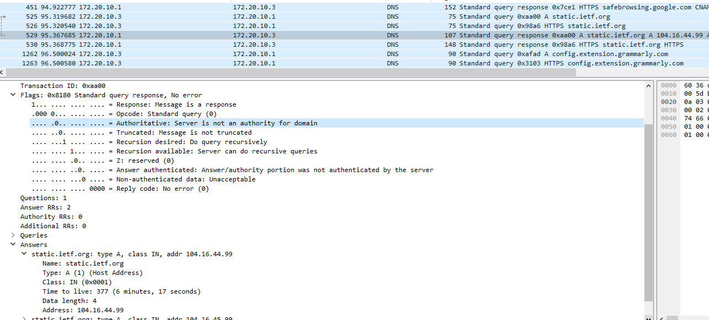

Q1: This is a response message from the DNS server to the client. What was the query?

Q2: What is the IP address of the requested server (static.ietf.org)?

Q3: What is the IP address of the DNS server and what does it represent??

Q4: what is the IP address of the client?

Q5: How Many answers the clients receive?

Q6: What is the type of the DNS record? What does it stands for? Mention other possible records?