|  |  |  |  |
| --- | --- | --- | --- |
| QFO-AP-VA-008 | **رمز النموذج :** | **اسم النموذج :** خطة تدريس مادة دراسية | **جامعة فيلادلفيا**  Philadelphia University |
| 1 | **رقم الإصدار: (Revision)** | **الجهة المصدرة:**  نائب الرئيس للشؤون الأكاديمية |
| 7-3-2019 | **تاريخ الإصدار:** | **الجهة المدققة :** اللجنة العليا لضمان الجودة |
| 1 | **عدد صفحات النموذج :** |

**Faculty of Arts**

**Department of English Language and Literature**

**First Semester, 2020/ 21**

|  |  |
| --- | --- |
| **Course Syllabus** | |
| **Course code:** 0120214 | | **Advanced Reading** | |
| **Course prerequisite:** 120113 | | **Course Level:** Second year | |
| **Credit hours:** 3 | | **Lecture Time:** 10.10- 11.00 | |

|  |  |  |  |  |
| --- | --- | --- | --- | --- |
| **Academic Staff Specifics** | | | | |
| **E-mail Address** | **Office Hours** | **Office** | **Rank** | **Name** |
| nhamdi@philadelphia.edu.jo | Sun, Tue, Thu: 9.00- 10.00; Mon, Wed:9.45- 11.00 | 412 |  | Nadia Hamdi |

**[**

|  |  |
| --- | --- |
| **Date** | **Topic** |
| WEEK 1 | Introduction |
| WEEK 2 | The Adventure of the Speckled Band |
| WEEK 3 | Using a dictionary |
| WEEK 4 | Planet Earth is Blue by David Bowie |
| WEEK 5 | Dracula Lives on |
| WEEK 6 | According to Legend |
| WEEK 7 | Dictionary and contextual work |
| WEEK 8 | Adverbs |
| WEEK 9 | Famous speeches |
| WEEK 10 | The conventions of persuasion |
| WEEK 11 | Fire Safety |
| WEEK 12 | Fire Safety and protection |
| WEEK 13 | My mother saw a dancing bear |
| WEEK 14 | Writing narrative poetry |
| WEEK 15 | General Revision |

**t**

Week 1:

Welcome to our course on Advanced Reading

Please read each of the texts we assign carefully, take notes and keep a word log so you can keep track of your progress.

Read the list below and tell me which ones you believe are most important

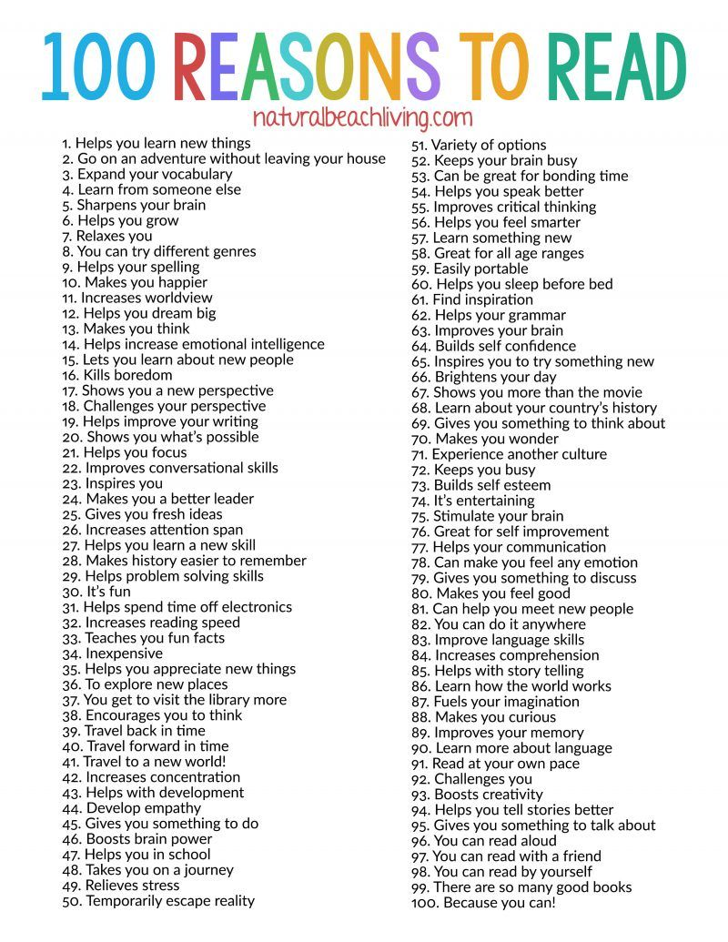

------------------------------------------------------

Week 2:

Video: https://etc.usf.edu/lit2go/32/the-adventures-of-sherlock-holmes/352/adventure-8-the-adventure-of-the-speckled-band/

------------------------------------------------------

Week 3:

Use a dictionary to find the meaning of the following words:

|  |  |  |
| --- | --- | --- |
| Word | Meaning | Part of Speech |
| Beamed |  |  |
| Colleague |  |  |
| rough |  |  |
| inordinately |  |  |
| depressed |  |  |
| concentration |  |  |

------------------------------------------------------

Week 4:

Listen to the song and write down your ideas about it so we can answer questions about it in class.

<https://www.youtube.com/watch?v=9_M3uw29U1U>

------------------------------------------------------

Week 5:

# [Excerpt from “Dracula” by Bram Stoker ~~Lucy~~](https://thingsthatmadeanimpression.wordpress.com/2016/01/11/excerpt-from-dracula-by-bram-stoker-lucy/)

[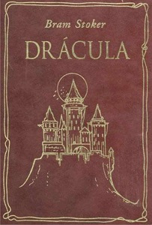](https://thingsthatmadeanimpression.wordpress.com/2016/01/11/excerpt-from-dracula-by-bram-stoker-lucy/picture-dracula-stoker/)When all was ready, Van Helsing said:—  
“Before we do anything, let me tell you this; it is out of the lore and experience of the ancients and of all those who have studied the powers of the Un-Dead. When they become such, there comes with the change the curse of immortality; they cannot die, but must go on age after age adding new victims and multiplying the evils of the world; for all that die from the preying of the Un-Dead becomes themselves Un-Dead, and prey on their kind. And so the circle goes on ever widening, like as the ripples from a stone thrown in the water. Friend Arthur, if you had met that kiss which you know of before poor Lucy die; or again, last night when you open your arms to her, you would in time, when you had died, have become nosferatu, as they call it in Eastern Europe, and would all time make more of those Un-Deads that so have fill us with horror. The career of this so unhappy dear lady is but just begun. Those children whose blood she suck are not as yet so much the worse; but if she live on, Un-Dead, more and more they lose their blood and by her power over them they come to her; and so she draw their blood with that so wicked mouth. But if she die in truth, then all cease; the tiny wounds of the throats disappear, and they go back to their plays unknowing ever of what has been. But of the most blessed of all, when this now Un-Dead be made to rest as true dead, then the soul of the poor lady whom we love shall again be free. Instead of working wickedness by night and growing more debased in the assimilating of it by day, she shall take her place with the other Angels. So that, my friend, it will be a blessed hand for her that shall strike the blow that sets her free. To this I am willing; but is there none amongst us who has a better right? Will it be no joy to think of hereafter in the silence of the night when sleep is not: ‘It was my hand that sent her to the stars; it was the hand of him that loved her best; the hand that of all she would herself have chosen, had it been to her to choose?’ Tell me if there be such a one amongst us?”  
We all looked at Arthur. He saw, too, what we all did, the infinite kindness which suggested that his should be the hand which would restore Lucy to us as a holy, and not an unholy, memory; he stepped forward and said bravely, though his hand trembled, and his face was as pale as snow:—  
“My true friend, from the bottom of my broken heart I thank you. Tell me what I am to do, and I shall not falter!” Van Helsing laid a hand on his shoulder, and said:—  
“Brave lad! A moment’s courage, and it is done. This stake must be driven through her. It will be a fearful ordeal—be not deceived in that—but it will be only a short time, and you will then rejoice more than your pain was great; from this grim tomb you will emerge as though you tread on air. But you must not falter when once you have begun. Only think that we, your true friends, are round you, and that we pray for you all the time.”  
“Go on,” said Arthur hoarsely. “Tell me what I am to do.”  
“Take this stake in your left hand, ready to place the point over the heart, and the hammer in your right. Then when we begin our prayer for the dead—I shall read him, I have here the book, and the others shall follow—strike in God’s name, that so all may be well with the dead that we love and that the Un-Dead pass away.”  
Arthur took the stake and the hammer, and when once his mind was set on action his hands never trembled nor even quivered. Van Helsing opened his missal and began to read, and Quincey and I followed as well as we could. Arthur placed the point over the heart, and as I looked I could see its dint in the white flesh. Then he struck with all his might.  
The Thing in the coffin writhed; and a hideous, blood-curdling screech came from the opened red lips. The body shook and quivered and twisted in wild contortions; the sharp white teeth champed together till the lips were cut, and the mouth was smeared with a crimson foam. But Arthur never faltered. He looked like a figure of Thor as his untrembling arm rose and fell, driving deeper and deeper the mercy-bearing stake, whilst the blood from the pierced heart welled and spurted up around it. His face was set, and high duty seemed to shine through it; the sight of it gave us courage so that our voices seemed to ring through the little vault.  
And then the writhing and quivering of the body became less, and the teeth seemed to champ, and the face to quiver. Finally it lay still. The terrible task was over.

------------------------------------------------------

Week 6:



------------------------------------------------------

Week 7:

Dictionary and contextual work

Guess the meaning of the following words from the context. If you don’t know the meaning use a dictionary to help you

|  |  |
| --- | --- |
| Vicious |  |
| Supernaturally |  |
| Reanimates |  |
| Rabid |  |
| Sultry |  |
| Emerge |  |
| Paralyzed |  |
| Pursue |  |
| Proposed |  |
| Thereafter |  |
| Scudding |  |
| Mangled |  |

------------------------------------------------------

Week 8:

Adverbs tell us more about a verb. They tell us more about *how*, *when*, or *where* the action of a verb takes place.

In the table below, write each adverb in the correct column

|  |  |  |
| --- | --- | --- |
| How | When | Where |
|  |  |  |
|  |  |  |
|  |  |  |
|  |  |  |
|  |  |  |
|  |  |  |

------------------------------------------------------

Week 9:

Video: https://www.americanrhetoric.com/speeches/mlkihaveadream.htm

------------------------------------------------------

Week 10:

**The conventions of persuasion**

Find five key points from Martin Luther King’s speech and explain which persuasive device is used for each one.

|  |  |
| --- | --- |
| Key points | Persuasive device |
|  |  |
|  |  |
|  |  |
|  |  |
|  |  |

------------------------------------------------------

Week 11:

Video: https://www.redcross.org/get-help/how-to-prepare-for-emergencies/types-of-emergencies/fire.html

------------------------------------------------------

Week 12

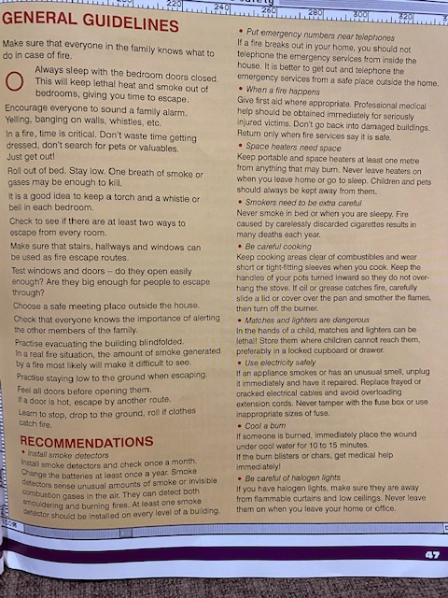

Week 13:



------------------------------------------------------

Week 14:

The strength of the expression in this poem comes from the stark contrast between the happiness in the first three stanzas and the final two

The mother is in the schoolyard on a summer’s day

The performance of the bear

The enjoyment of the audience.

However, in the last two stanzas, the tone changes creating a different mood and thus changing our viewpoint.

Write a narrative poem from the viewpoint of the bear. Describe how he came to be a dancing bear and how he feels about it.

------------------------------------------------------

Week 15: