|  |  |  |  |
| --- | --- | --- | --- |
| QFO-AP-VA-008 | **رمز النموذج :** | **اسم النموذج :** خطة تدريس مادة دراسية | **جامعة فيلادلفيا**  Philadelphia University |
| 1 | **رقم الإصدار: (Revision)** | **الجهة المصدرة:**  نائب الرئيس للشؤون الأكاديمية |
| 7-3-2019 | **تاريخ الإصدار:** | **الجهة المدققة :** اللجنة العليا لضمان الجودة |
| 1 | **عدد صفحات النموذج:** |

**Faculty of Arts**

**Department of English Language and Literature**

**First Semester, 2020/ 21**

|  |  |
| --- | --- |
| **Course Syllabus** | |
| **Course code:** 0120463 | | Methods of teaching 2 | |
| **Course prerequisite:** 120462 | | **Course Level:** 4th year | |
| **Credit hours:** 3 | | **Lecture Time:** 8.15- 9.45 | |

|  |  |  |  |  |
| --- | --- | --- | --- | --- |
| **Academic Staff Specifics** | | | | |
| **E-mail Address** | **Office Hours** | **Office** | **Rank** | **Name** |
| nhamdi@philadelphia.edu.jo | Sun, Tue, Thu: 9.00- 10.00; Mon, Wed:9.45- 11.00 | 412 |  | Nadia Hamdi |

**[**

|  |  |
| --- | --- |
| **Date** | **Topic** |
| WEEK 1 | Introduction |
| WEEK 2 | Cultural Stereotypes  Attitudes |
| WEEK 3 | Acculturation  Culture in the Classroom |
| WEEK 4 | Acculturation  A principled Approach to Language Pedagogy |
| WEEK 5 | The Contrastive Analysis Hypothesis  Hierarchy of Difficulty |
| WEEK 6 | Markedness and Universal Grammar  Error Analysis |
| WEEK 7 | Sources of Error  Fossilization |
| WEEK 8 | Error Correction |
| WEEK 9 | Communicative Competence- Pragmatics  Language functions |
| WEEK 10 | Styles and Registers  Language and Gender |
| WEEK 11 | Nonverbal communication |
| WEEK 12 | Language Testing- what is it? |
| WEEK 13 | Kinds of Tests |
| WEEK 14 | Oral Proficiency Testing |
| WEEK 15 | General Revision |

**t**

Week 1:



Welcome to Methods of Teaching 2

Week 2:

Teaching and learning languages involve more than targeting grammatical and lexical knowledge. To achieve communicative competence in English as a Foreign Language (EFL) context, EFL learners need to develop their intercultural competence

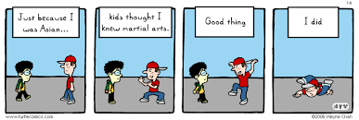

Week 3:

------------------------------------------------------

Week 4:

Video: https://study.com/academy/lesson/using-intrinsic-and-extrinsic-motivation-to-enhance-learning.html

Web Link: https://www.teachingenglish.org.uk/article/intrinsic-motivation

------------------------------------------------------

Week 5:

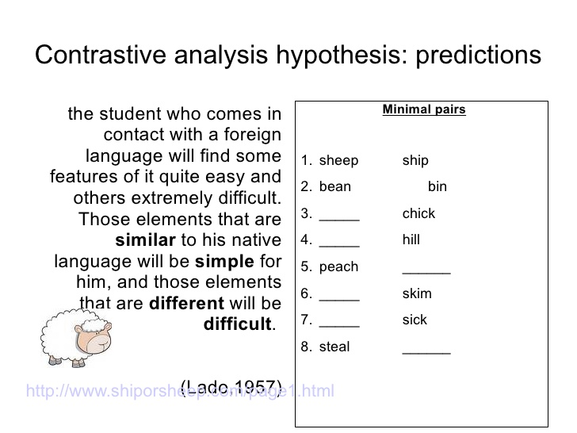

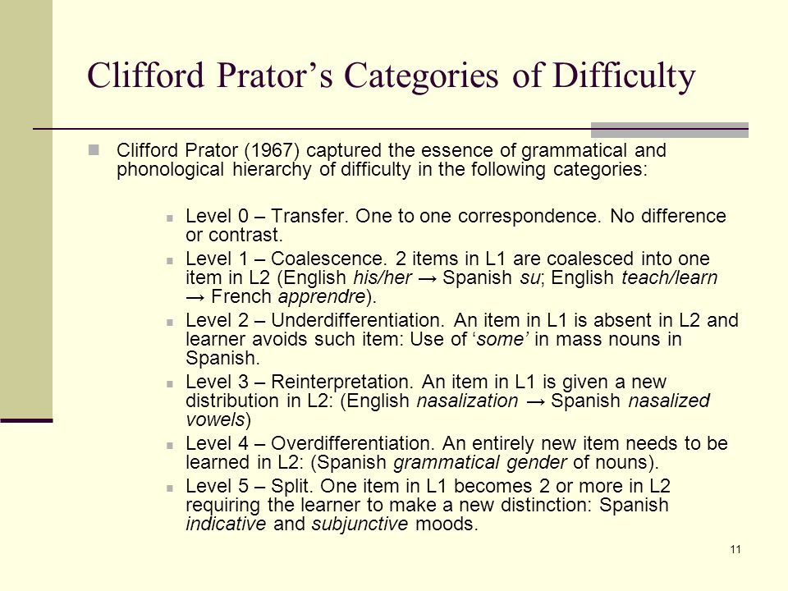

------------------------------------------------------

Week 6:

Files or Handouts (Word, PPT, PDF):

Video:

Web Link:

------------------------------------------------------

Week 7:

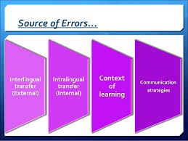

Web Link:

https://www.teachingenglish.org.uk/article/fossilization#:~:text=Fossilization%20refers%20to%20the%20process,could%20be%20a%20fossilized%20error.

------------------------------------------------------

Week 8:

------------------------------------------------------

Week 9:

------------------------------------------------------

Week 10:

Video:

Web Link: https://www.thoughtco.com/gender-in-sociolinguistics-1690888#:~:text=In%20sociolinguistics%20and%20other%20social,relation%20to%20culture%20and%20society.&text=In%20the%20U.S.%2C%20the%20interdisciplinary,and%20Woman's%20Place%20(1975).

------------------------------------------------------

Week 11:

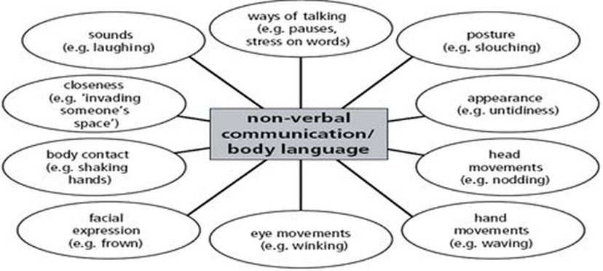

------------------------------------------------------

Week 12:

https://www.cambridgeenglish.org/research-and-validation/about-language-testing/

------------------------------------------------------

Week 13:

Files or Handouts (Word, PPT, PDF):

Video:

Web Link:

------------------------------------------------------

Week 14:

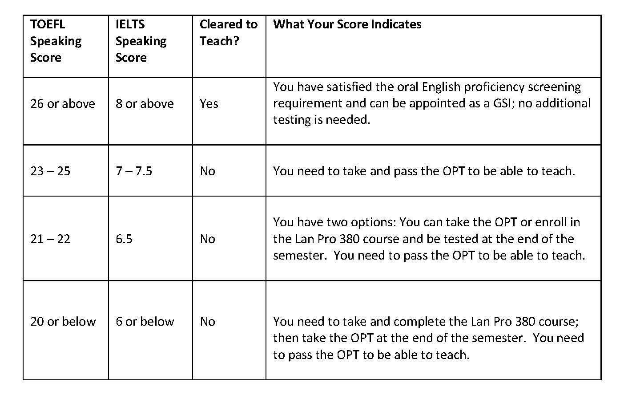

------------------------------------------------------

Week 15:

Hope you enjoyed the course

Good luck on the final